***Library Rush: Playtest feedback***

Please fill out each section with thoughts or suggestions from your playtesting session

Controls:

Didn’t like at first, but made it a lot more enjoyable in the long run. Would have been quite mundane otherwise

Gameplay:

Complaints bar isn’t updating

Maybe the displayed objective in the top right can be the most recent one? Unsure if this would add anything as only realised tab opened it right at the end so it was screwing with my movement for the rest of the game. Something to play with maybe :P

Difficulty:

Good and steady increase, but sad there were no more mechanics as would have loved another one.

Design:

No idea how to help customers at first.

Genuinely really enjoyable game. Great job :D

Sounds:

Menu music is nice and calm. Sounds like a library

Bugs:

Clicking objectives bar picks up books when in section

Other:

😊

UI:

Level select inside level 3

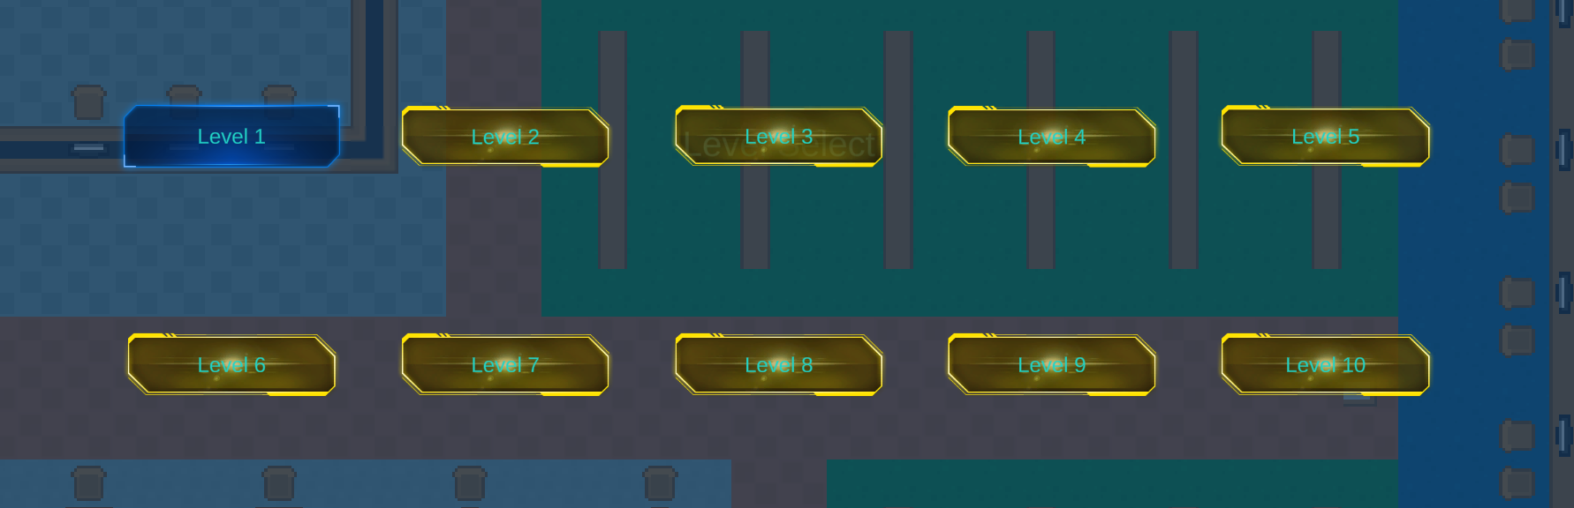

Volume slider not staying in bounds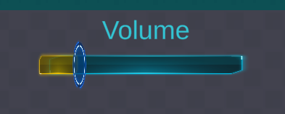

Orange bars indicate 0 to max volume area